**Faculty of Computing**

**Year 2 Semester 1 (2025)**

**IT2120 - Probability and Statistics**

**Lab Sheet 04**

**IT24102513**

**Ranjanaramya L**

**Exercise**

**1.**

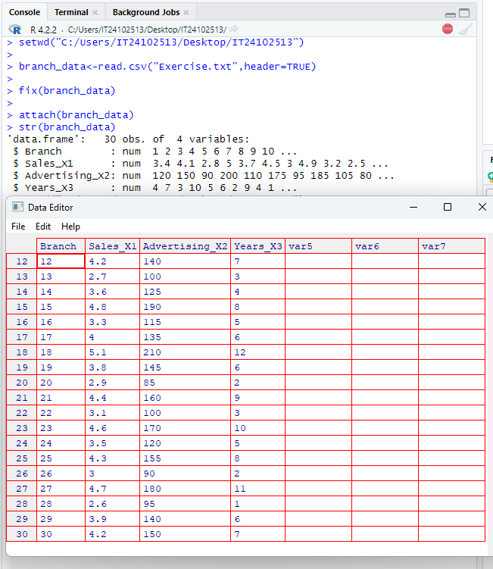

**2.**

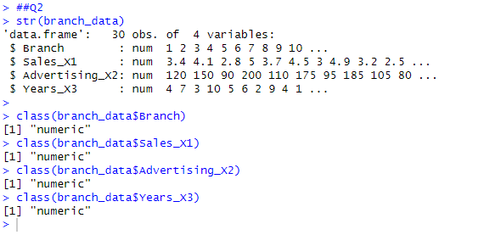

**3.**



**4.**

**5.**

